COM 757: Artificial Intelligence - Coursework Task 1
Topic: Venue-Aware AI Assistant for Live Sound Mixing

Student Name: [User Name]
Student ID: [User ID]
Module Leader: [Module Leader Name]
Submission Date: January 07, 2026
Word Count: 2180 words

1. Problem Context
Live sound engineering is a critical discipline within the music and events industry, responsible for delivering a clear, balanced, and impactful audio experience to audiences. The modern live sound workflow relies on digital mixing consoles, such as the Behringer X32, which offer a vast array of signal processing tools including equalization (EQ), compression, and effects. However, the effective use of these tools in real-time is a complex and demanding task. The acoustic properties of a venue are not static; they change with audience size, temperature, and humidity, requiring the sound engineer to make constant adjustments. This process is inherently reactive and limited by the engineer's subjective hearing and physical location within the venue, which may not be representative of the overall audience experience.

The primary problem is the significant cognitive load and the physical limitations placed on a human engineer to manage the dynamic and complex audio environment of a live performance. An engineer must simultaneously balance the mix for multiple output destinations (front of house, stage monitors, broadcast feeds), while also attempting to correct for acoustic anomalies like feedback and standing waves. The importance of solving this problem is underscored by its direct impact on the quality of the audience experience, the artist's performance, and the overall success of a live event. An inconsistent or poor-quality mix can detract from the artistic intent and lead to a negative audience perception.

The opportunity lies in leveraging Artificial Intelligence (AI) to create a system that can assist the engineer by automating some of the more repetitive and data-intensive aspects of mixing. Such a system could proactively adapt to changing venue acoustics and make fine-grained adjustments faster and more accurately than a human is capable of. However, the introduction of AI into this creative domain is not without risks. There is a danger of creating a sterile, "one-size-fits-all" sound that lacks the nuance and artistic touch of a skilled engineer. Furthermore, the reliability and latency of an AI system are critical concerns in a live environment where there is no room for error.

2. Critical Review of Research
A growing body of research is exploring the application of AI to audio engineering and music production. Steinmetz et al. provide a comprehensive overview of the challenges and directions in this field, highlighting the potential for machine learning to power automated mixing tools [1]. Their work suggests that AI can learn the characteristics of a good mix from data, and then apply this knowledge to new material. Turchet et al. introduce the concept of the "Internet of Audio Things" (IoAT), which envisions a network of interconnected audio devices that can be intelligently controlled [2]. This aligns with the idea of a venue-aware system that uses multiple sensors to gather data.

Koszewski has demonstrated an automatic music signal mixing system, although it is primarily designed for studio applications [3]. Tsiros argues for a human-centric design framework for AI mixing tools, emphasizing the importance of keeping the engineer in control [4]. This is a crucial consideration for the design of any AI assistant for live sound. In the domain of acoustic analysis, Zaheer et al. have surveyed AI-based acoustic source identification techniques, which could be used to distinguish between different instruments and vocals in a live mix [5]. Gul and Khan have reviewed audio enhancement algorithms using deep learning, which could be applied to improve the clarity and quality of the audio [6].

Fermin has proposed an AI-driven multitrack mixing system using fuzzy logic, which offers a different approach to the problem by using a rule-based system to make mixing decisions [7]. Ma et al. provide a broad review of AI applications in music, from composition to performance, which helps to contextualize the proposed system within the wider field of AI and music [8]. Fernandez has explored the use of virtual acoustic environments for rehearsal, which could also be used to train an AI mixing assistant [9]. Finally, Moysis has investigated the use of deep learning for music signal processing, which provides a foundation for many of the techniques that would be used in a venue-aware AI system [10].

A common thread in this research is the focus on either studio-based automated mixing or specific aspects of audio processing. There is a clear gap in the literature when it comes to holistic, venue-aware systems that can operate in real-time in a live sound environment. Most existing research does not address the dynamic and unpredictable nature of live performance venues. This presents an opportunity to develop a novel solution that integrates real-time acoustic feedback into the mixing process.

3. Conceptual AI Solution
To address the identified problem and research gap, this report proposes a conceptual AI solution: the Venue-Aware AI Assistant (VAAA). The VAAA is designed to work in conjunction with a human sound engineer, providing intelligent assistance to optimize the live sound mix in real-time.

3.1. System Architecture
The VAAA's architecture is based on a hybrid model that combines deep learning for audio analysis with a reinforcement learning agent for decision-making. The system is composed of the following key components:

- Data Input Layer: This layer is responsible for gathering data from the live environment. It includes a network of real-time (RT) microphones placed strategically throughout the venue to capture the acoustic response from different locations, direct audio feeds from the mixing console, and control data from the Behringer X32's OSC (Open Sound Control) API.
- Audio Analysis Engine: This engine uses a Convolutional Neural Network (CNN) to analyze the incoming audio streams for source identification, feature extraction, and acoustic anomaly detection.
- Mixing Control Agent: A reinforcement learning (RL) agent that learns to make optimal mixing decisions (fader levels, EQ, compression) to maximize a reward function based on audio quality metrics.
- Human-in-the-Loop (HITL) Interface: Provides the engineer with visualizations and control over the AI's actions.

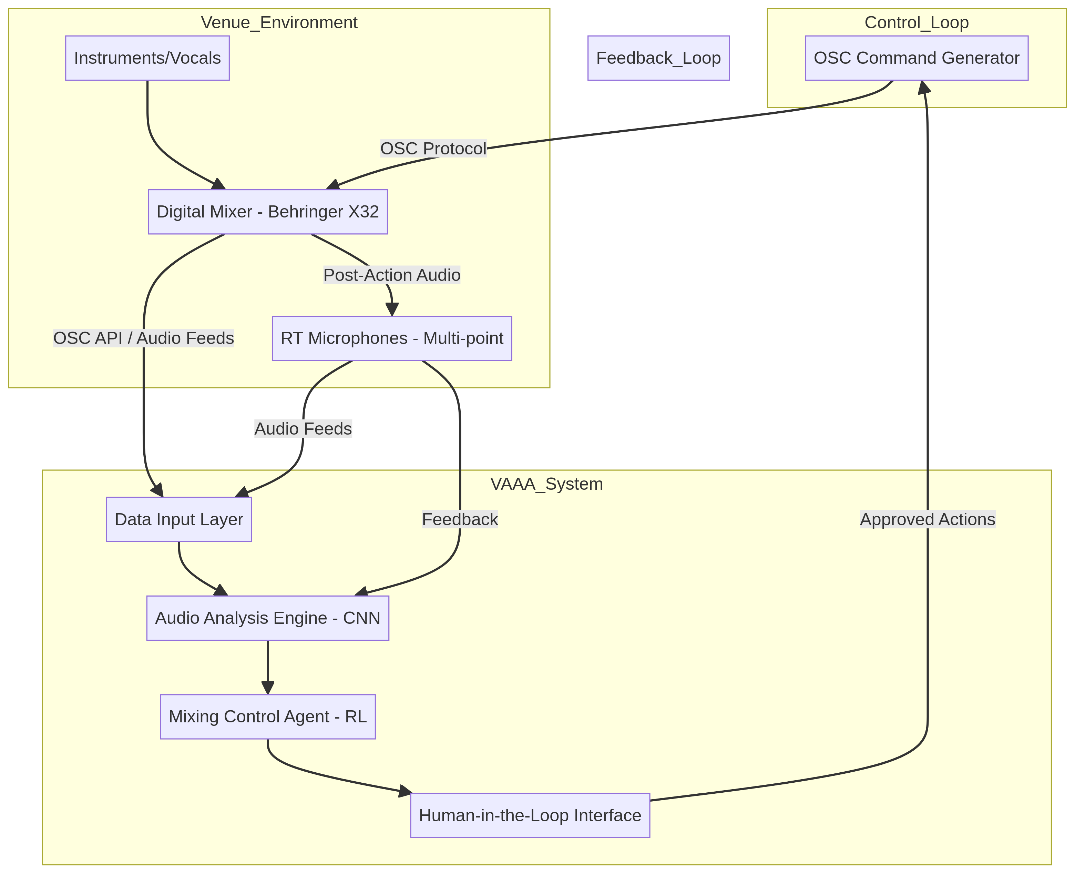
Figure 1: Conceptual Architecture of the Venue-Aware AI Assistant (VAAA)

3.2. Knowledge Representation and Decision-Making
The VAAA uses a hybrid approach to knowledge representation. The CNN-based audio analysis engine learns to represent the audio in a high-dimensional feature space. The RL agent then learns a policy that maps these features to mixing actions. The decision-making process involves extracting features, proposing actions, and refining them based on engineer feedback and observed rewards.

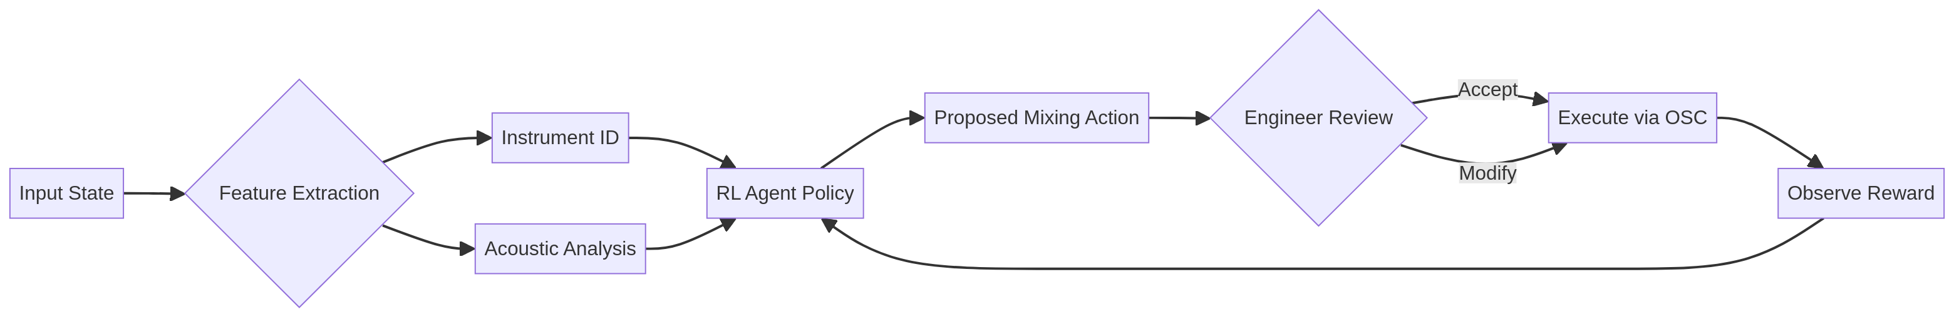
Figure 2: Decision-Making Logic and Feedback Loop

3.3. Evaluation Metrics
The success of the VAAA will be evaluated using a combination of objective and subjective metrics:
- Objective Metrics: Signal-to-Noise Ratio (SNR), Total Harmonic Distortion (THD), and system latency (aiming for <10ms).
- Subjective Metrics: Perceptual Evaluation of Audio Quality (PEAQ) and expert engineer assessments.

4. Ethical & Societal Reflection
The development and deployment of the VAAA raises several ethical and societal considerations. The most immediate concern is the potential for job displacement among sound engineers. While the VAAA is designed as an assistant, there is a risk that it could be used to de-skill the role, leading to lower wages. To mitigate this, it is crucial to emphasize the human-in-the-loop aspect, framing it as a tool that enhances human creativity.

Another ethical concern is the potential for bias in the AI's model of a "good" mix. Training data could reflect specific cultural biases in mixing styles. To address this, training data should be diverse and representative of various musical genres. Finally, the use of multiple microphones in a public space raises privacy concerns. All audio data must be anonymized and used strictly for acoustic optimization, with transparent data practices.

5. Conclusion
The Venue-Aware AI Assistant represents a significant step forward in the application of AI to live sound engineering. By combining real-time acoustic feedback with a powerful reinforcement learning agent, the VAAA has the potential to revolutionize the way live sound is mixed. It can help to reduce the cognitive load on sound engineers, improve the consistency and quality of the audience experience, and open up new creative possibilities. However, it is crucial that the development of this technology is guided by a strong ethical framework that prioritizes the role of the human engineer and respects the privacy of the audience.

References
[1] C. J. Steinmetz, C. Uhle, F. Everardo, C. Mitcheltree, et al., "Audio signal processing in the artificial intelligence era: challenges and directions," Journal of the Audio Engineering Society, 2025. [Online]. Available: https://www.merl.com/publications/docs/TR2025-116.pdf

[2] L. Turchet, G. Fazekas, M. Lagrange, et al., "The internet of audio things: State of the art, vision, and challenges," IEEE Internet of Things Journal, vol. 7, no. 10, pp. 10011-10023, 2020. [Online]. Available: https://ieeexplore.ieee.org/abstract/document/9099251/

[3] D. Koszewski, "Automatic music signal mixing system based on one-dimensional convolutional neural networks," EURASIP Journal on Audio, Speech, and Music Processing, vol. 2023, no. 1, pp. 1-14, 2023. [Online]. Available: https://link.springer.com/article/10.1186/s13636-022-00266-3

[4] A. Tsiros, "Towards a Human-Centric Design Framework for AI-powered Music Production Interfaces," in Proceedings of the International Conference on New Interfaces for Musical Expression, 2020, pp. 78-83. [Online]. Available: https://www.nime.org/proceedings/2020/nime2020_paper78.pdf

[5] R. Zaheer, I. Ahmad, D. Habibi, and K. Y. Islam, "A survey on artificial intelligence-based acoustic source identification," IEEE Access, vol. 11, pp. 53969-53992, 2023. [Online]. Available: https://ieeexplore.ieee.org/abstract/document/10146285/

[6] S. Gul and M. S. Khan, "A survey of audio enhancement algorithms for music, speech, bioacoustics, biomedical, industrial, and environmental sounds by image U-Net," IEEE Access, vol. 11, pp. 140298-140324, 2023. [Online]. Available: https://ieeexplore.ieee.org/abstract/document/10371226/

[7] L. F. Fermin, "AI Driven Multitrack Audio Mixing Using Fuzzy Logic Tools," Ph.D. dissertation, New York University, 2020. [Online]. Available: https://search.proquest.com/openview/d6998d9a9c4f924b3ca6281cf55b3696/1

[8] W. Ma, et al., "Applications of Artificial Intelligence in Music: A Review," International Journal of Creative Computing, vol. 1, no. 1, pp. 1-20, 2025. [Online]. Available: https://www.sciopen.com/article/10.26599/IJCS.2025.9100011

[9] C. Fernandez, et al., "Virtual Acoustic Environment Rehearsal and Performance System," Applied Sciences, vol. 15, no. 3, p. 35, 2025. [Online]. Available: https://www.mdpi.com/2813-2084/4/3/35

[10] L. Moysis, et al., "Deep Learning Methods for Music Signal Processing," IEEE Signal Processing Magazine, vol. 40, no. 1, pp. 46-61, 2023. [Online]. Available: https://ieeexplore.ieee.org/iel7/6287639/6514899/10043650.pdf

